Writing task-1
The figure gives information about smoking habits of the UK population by age.
Summarise the information by selecting and reporting the main features, and make comparisons where relevant.You should spend about 20 minutes on this task. You should write at least 150 words.

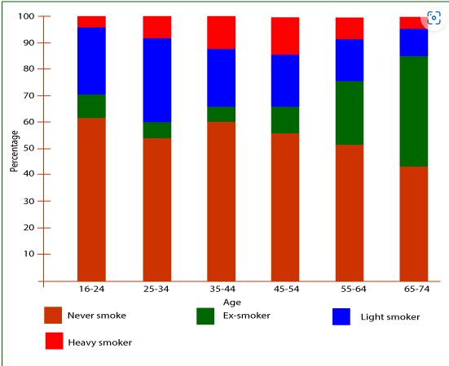

Task -2
You should spend about 40 minutes on this task,
Nowadays museums and historical sites are mainly visited by foreign tourists instead of locals. Why is this happening? What can be done to get locals to visit museums and historical sites more?
Give reasons for your answer and include any relevant examples from your own knowledge or experience.
Write at least 250 words.

Task-01
You should spend about 20 minutes on this task.
Your employer has recently allowed some employees to work remotely from home. You would also like to work from home. Write a letter to the HR manager for permission to work from home for the next six months.
In your letter,
- mention why you are writing
- explain why you would like to work from home
- say how this can benefit you and the company
Write at least 150 words.
You do NOT need to write any addresses.
Begin your letter as follows:
Dear Sir or Madam,

Task-02
You should spend about 40 minutes on this task.
Some cities have vehicle-free days when private cars, trucks, and motorcycles are banned from the city center. People are encouraged to use public transportation such as buses, taxis, and metro on vehicle-free days.
Do the advantages of this outweigh the disadvantages?
Give reasons for your answer and include any relevant examples from your own knowledge or experience.
Write at least 250 words.

